* **INSTALING NODE JS**

Node JS is the JS RUN TIME which add some features to JS so it can run of servers, so node js is just like other programming languages which can run on Systems (while js is for the browser purpose)

Node js use V8 which is Google compiler which takes the js code and convert into machine code in browser.

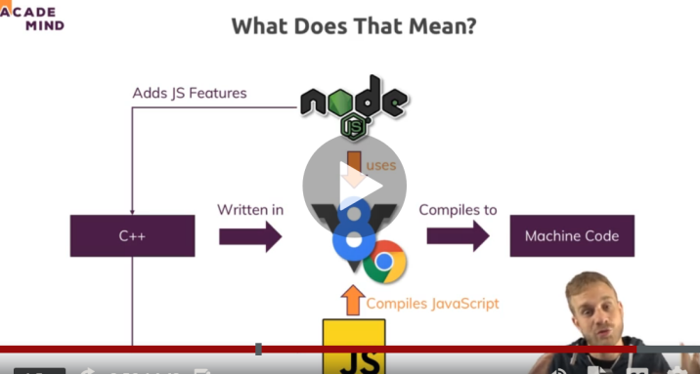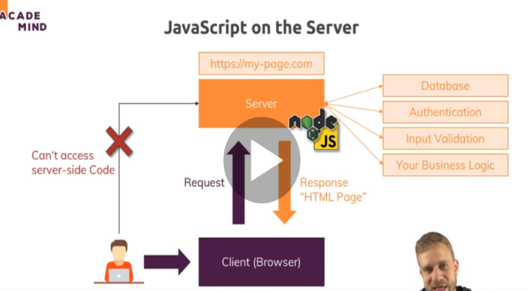

* Run node in vs code with terminal

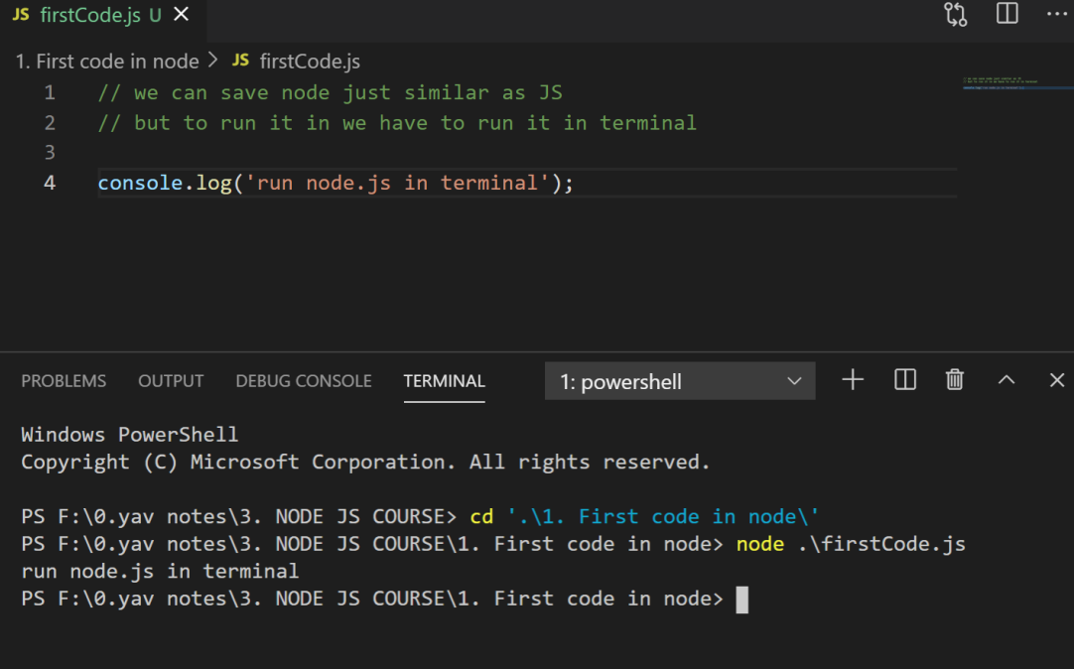

Q SO how node js is working in server side

So when user enters url this url converted by domain lookup and sends the request to the server side where node js plays a work to handles a data from data base and give response back to the client in form of html page.

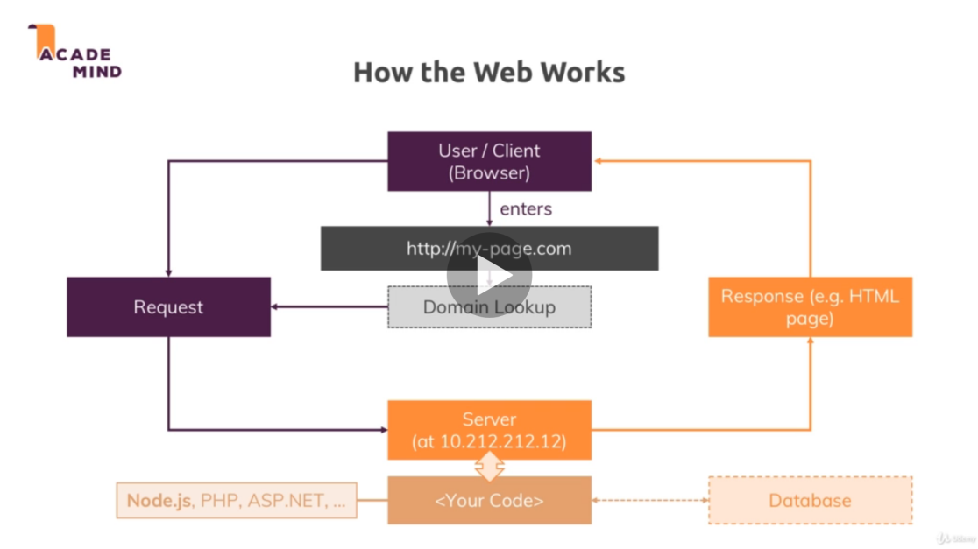

So to send from putting a request to getting it all the work done under standardized protocol which is HTTP and HTTPS but in https data is encrypted and secured.

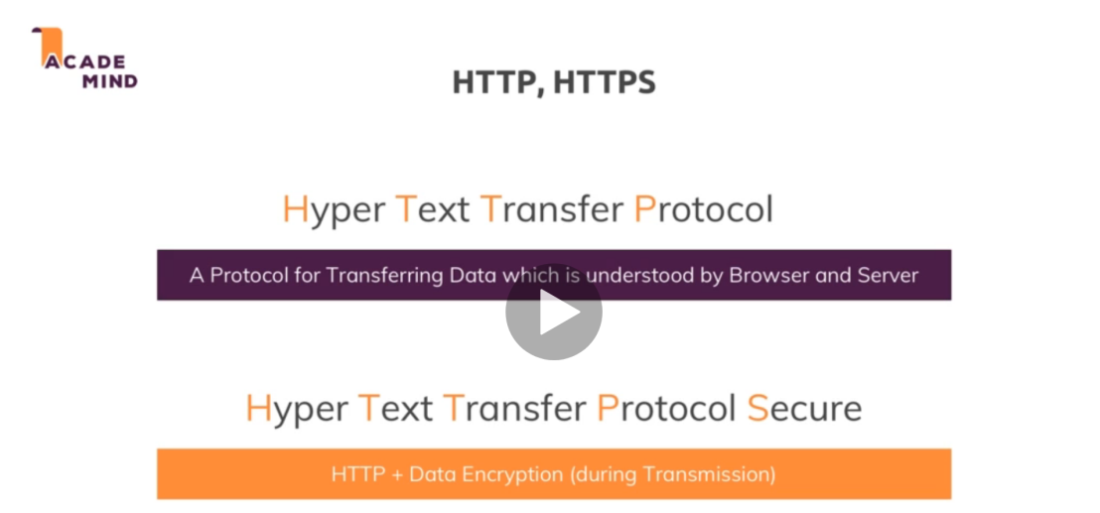

Some of the core module of node js which are most in use are

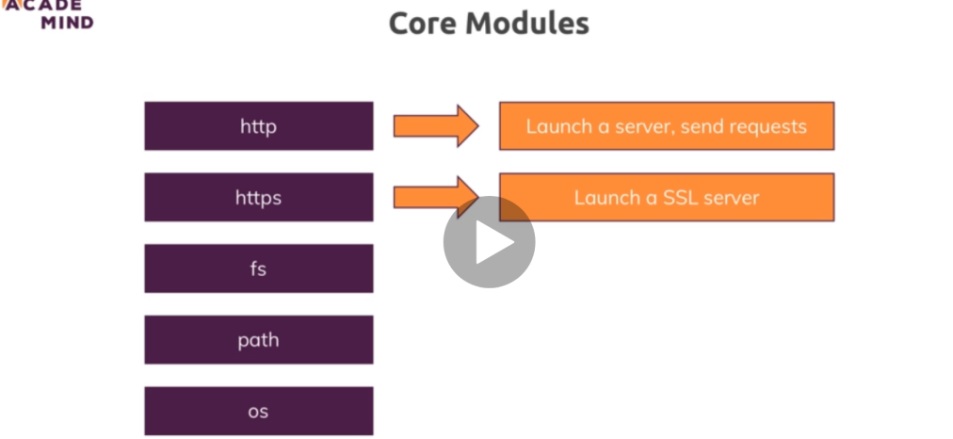

* How to write your own server in node Js

For that you have to get and save the path of the request some where which should be const for constant not changing 

Since the path is not defined therefore we using http only( but the actual path starts with (./http))

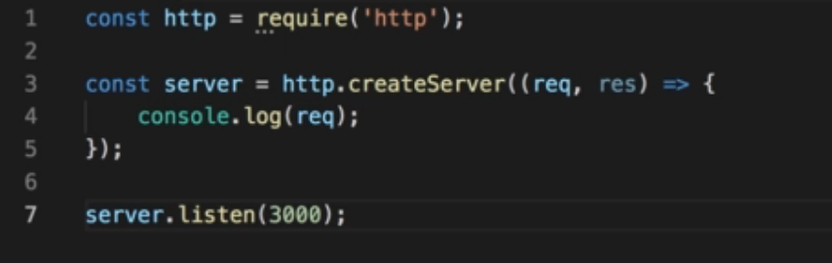

Here above we get request from the required(http) which is the local host or our net server and call a method from that http to create Server and print the request of it and after saving in server we listen the server by passing the port value greater then 1000 which is safe and her we do not pass other argument hostname which by default pass the local host and this keeps on listening request ( so when write localhost 3000 ) in our browser the it will listen to the browser. And you can check it by node in vs code

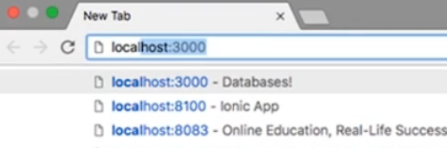

Node life cycle is when we call the node (file) it start scripting then parse and memorize the code and go to event loop and keeps on running until it listen the server it keeps on running so client can see the data so to exit it we use process.exit (when client do it.)

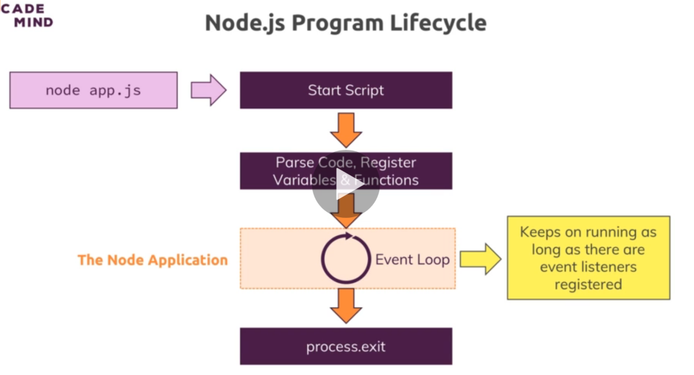

* Request in node js

So when we console the request we get whole bunch of data, variables and methods etc

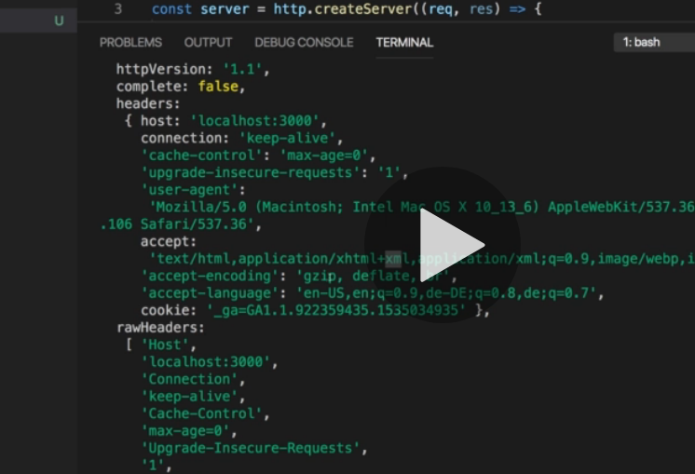

But we want only few to understand those are , request url, method and headers (headers contains the meta data)

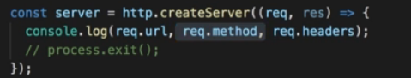

So here is the output in terminal

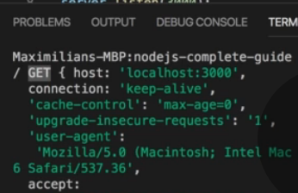

Which is (/) for the url because it is localhost (get) is for method and ( host : 🡪 below) is for header

* Response in Node js

So we can give response to the user/client side in node js can set header by res.setHeader(‘Content-Type, ‘text/html’) // so inside it we have to pass content Type.

We can also write a html code by our own inside the Js by res.write(); and when we have to push the our html code to the client that we have written have to use res.end() to end the response after this we can not write any res.write() html

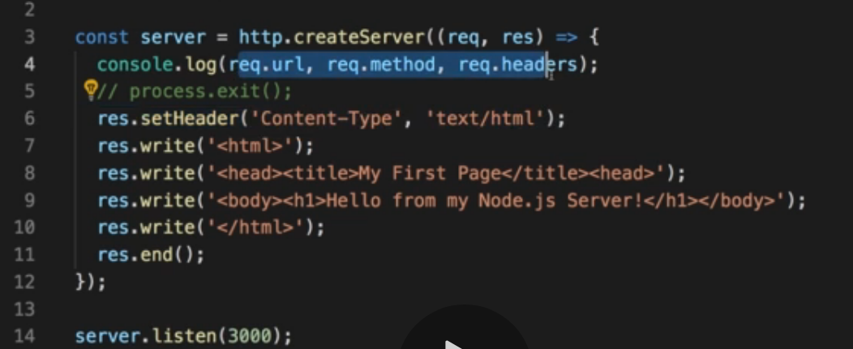

On both requests and responses, Http headers are added to transport metadata from A to B.

The following article provides a great overview of available headers and their role: <https://developer.mozilla.org/en-US/docs/Web/HTTP/Headers>

// her we create a local server

const http = require('http'); // get the url request

const fs = require('fs'); // fs enable us to work with the file system

const server = http.createServer((request,response) => { // crete server from teh url req. and its response

    const url = request.url;

    const method = request.method;

    if(url === '/') {

        response.write('<html>');

        response.write('<head><title> response in node </title></head>')

        response.write(`<body>

        <form action="/message" method="POST">

/* the action in the form will move the page to that/message*/

        <input type="text" name="message">

/* name message will be shown on the network  menu doc */

        <button type="submit">Send</button>

        </form>

        </body>`)

        response.write('</html>')

        return response.end(); // we have to return the after response end so it will not go down further because we do not write after response end

    }

    if(url === '/message' && method === 'POST') { // it will run only the above condition run

        fs.writeFileSync('message.txt','Dummy'); // it will create the file with of .txt

        response.statusCode = 302; // it sends for redirection 302 will redirect

        response.setHeader('Location','/') // it will locate the heder back to (/) home page

        return response.end();

    }

    console.log(request); // it keeps on running in the event loop

    // process.exit() // it is used to quit the server

    response.setHeader('Content-Type','text/html');

    response.write('<html>');  // it will write the in the response in form of html

    response.write('<head><title> response in node </title></head>')

    response.write('<body> this line written by response.write inside the node</body>')

    response.write('</html>')

    response.end();

})

server.listen(3000); // it will listen the server continuously with the port of 3000

// and the host name as local host by default if we do not pass so

// so when we write localhost 3000 in our browser it will console in our node

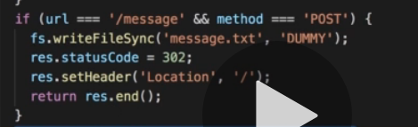

The above code set the status as 302and move page to back /

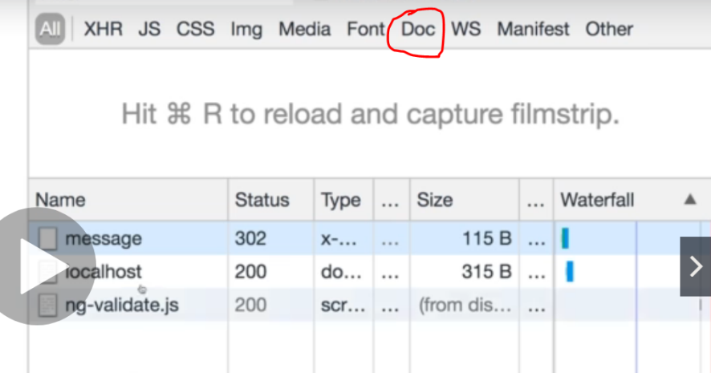

* Streams and buffer in node Js and the data

We are using streams and buffer so we can get the data that we stored in message above

Streams are the objects which lead you to read data from a source or write data to a destination in continues manner. We can say stream as live stream or streaming the movie and not downloading it. Stream will provide us data continuesly while we watching it

Buffer is the temporary chunk of data that is being transfer from one place to another in small amount without waiting the whole data to load.

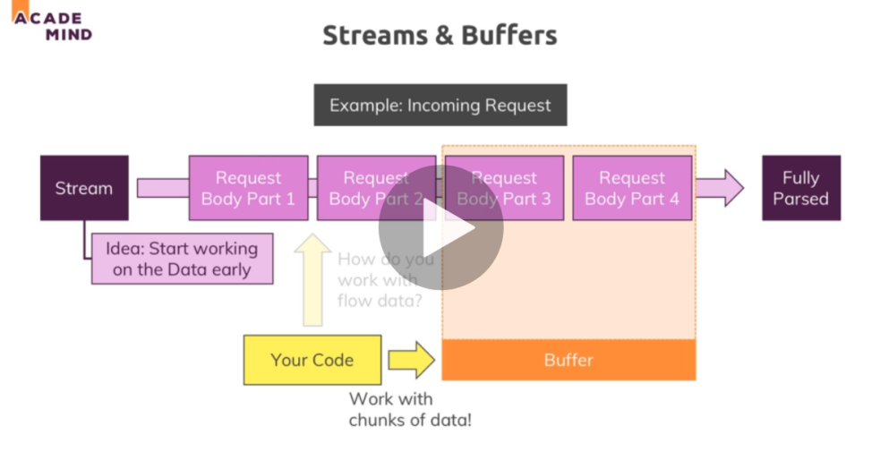

So to get the data have to listen the data first by event listener which is written as .a() 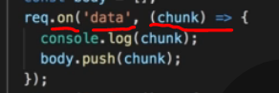 here the event is data and the we run the method on it when ever it pass the data and pushing in body array so we can use with buffer.

So we have to write another event that is (end) so when all the data passed at the end we can use the buffer as bus stop and convert it to string so that we can get the data as string

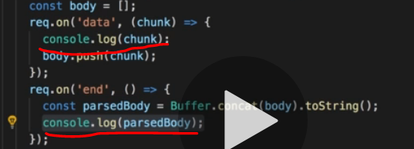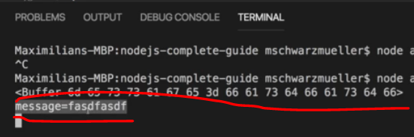

So the first red line is the console of first while (2 is the console of 2nd line)

The data is saved in key value pair which is message as key and = fasd----f as value

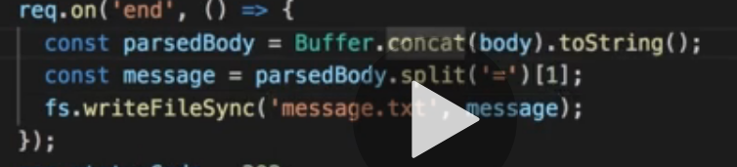

So above we storing our data at 1 index of split into message and writing a file containing message in our system.

* Event driven code and blocking and non blocking code

So event listener store that into registry because it is async in nature and run after all the code executes

The differernce between .writeFileSync and .writeFile is that .writeFileSync is Syncronus and if it is large file to write then it will block the code below so it is good to use .writeFile because it is async and run after the code completion.

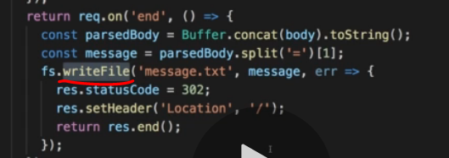

Node js just like java Script single threaded execute one line at a time and the event loop run the sync function first and then Async function after completing all line of code so the set time out will run from the call back queue when the call stack is empty

But in node all the methods and object made by (“fs”) will run inside the worker pool so that will do the heavy work of file

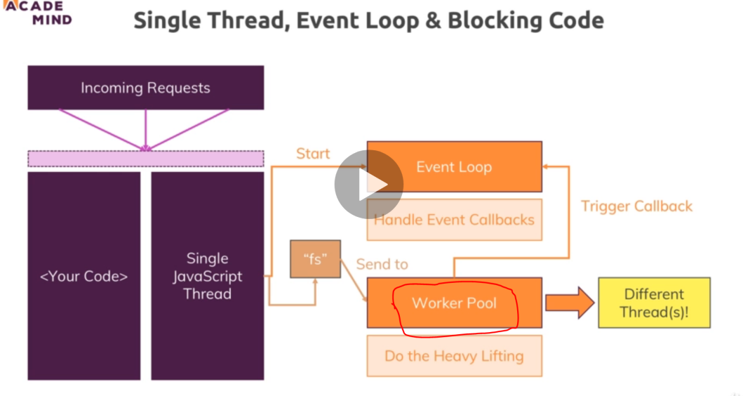

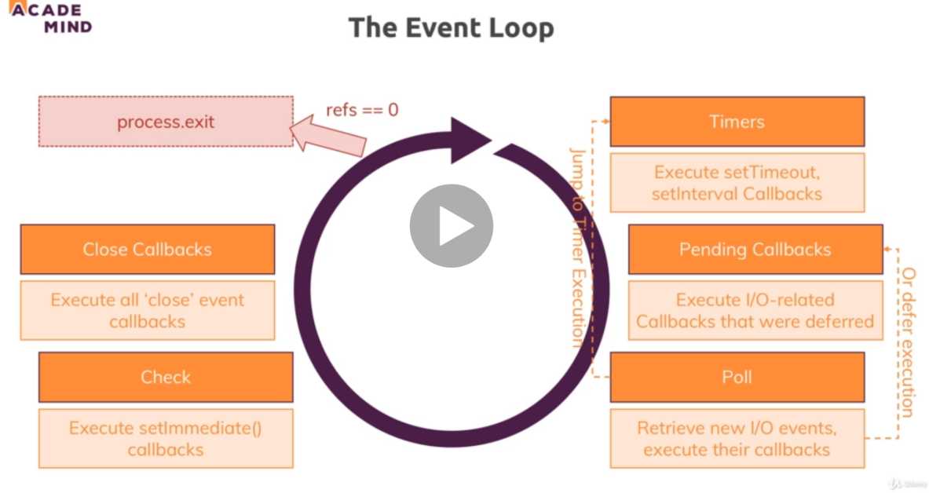

So event loop work on all this and run continues until (process exits)

Poll takes the i/o callbacks and send postponed callbacks to pending callbacks the timers will run simultaneously and jumping from poll to timers and timers to poll according to which done first

We can connect to Node js files with module.exports in

Second file

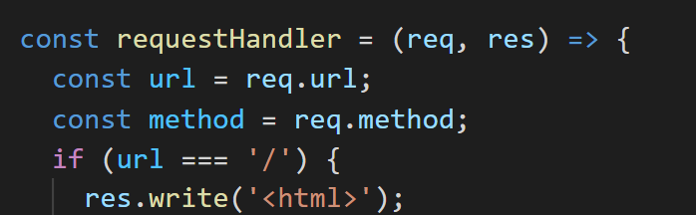

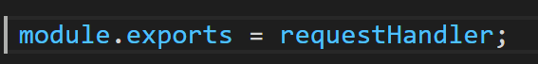

First file is

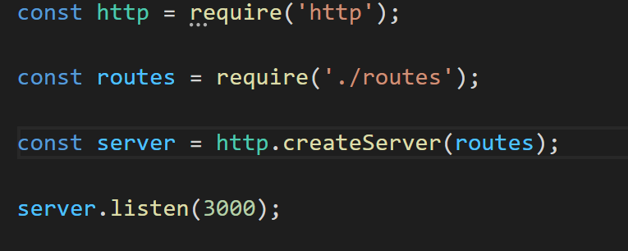 so when we pass routes then it passes the request and response inside as module .export

We can also write module export as

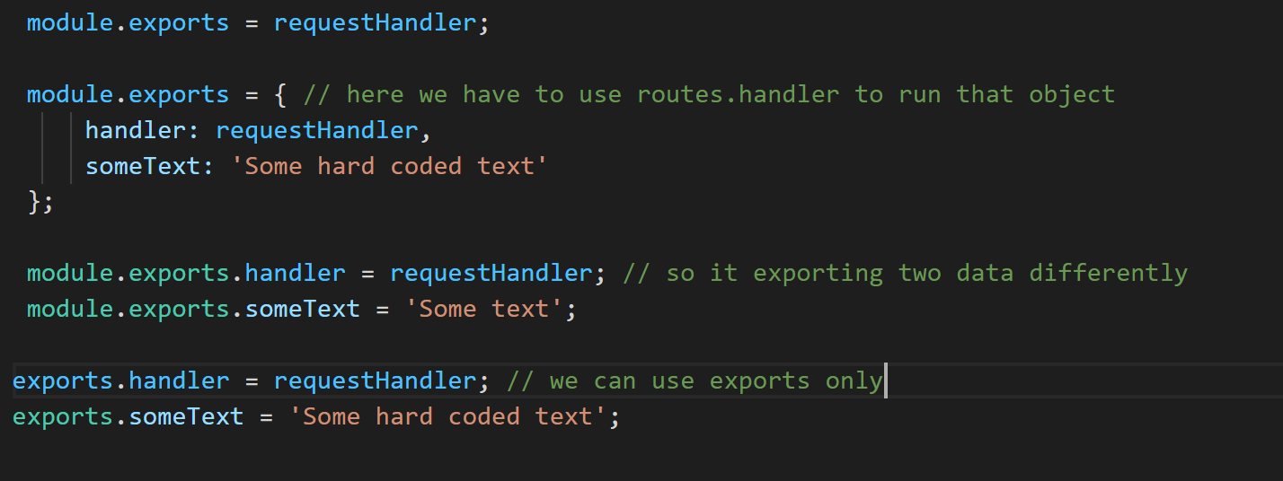

Useful Resources & Links

Attached, you find the source code for this section.

Useful resources:

* Official Node.js Docs: <https://nodejs.org/en/docs/guides/>
* Full Node.js Reference (for all core modules): <https://nodejs.org/dist/latest/docs/api/>
* More about the Node.js Event Loop: <https://nodejs.org/en/docs/guides/event-loop-timers-and-nexttick/>
* Blocking and Non-Blocking Code: <https://nodejs.org/en/docs/guides/dont-block-the-event-loop/>

**Use of npm in Node JS**  
npm is used to install 3rd party packages in our project and those packages are available in npm repository

And we can install a package using **npm install** which will get install from npm repository and if we write –g it will installed globally

So when you write npm install it will install the node module folder

IMP/ => **How to setup express with node**

So first we have to write npm init in terminal using git terminal or vs code terminal terminal should be opened in the project

After creating it a json file is created with the name (package.JSON) maybe so to use the npm scripting commands you have to write that command and what it will do inside the script of package.json like npm start you have to give the name of that file to start

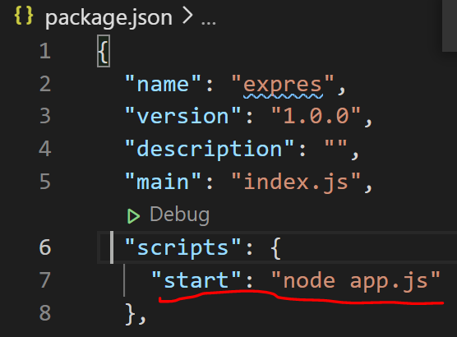

After that to install express you have to write npm install --save express

 we are doing it because we are not installing it in separate file instead we are adding dependencies in our package.json file

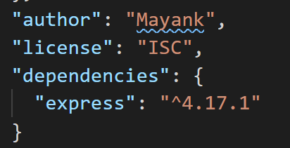

* EXPRESS JS

So we have to use express js with node js to buid the server side and server side api’s

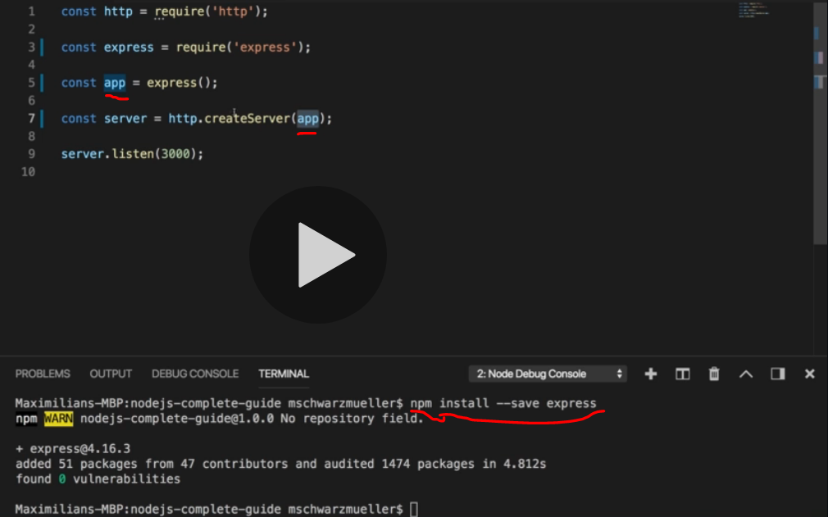

Here we are saving our express in our old file so we can use express from it by require so after saving in const we are saving it to an app as a function so that we can call it in server

So npm install –save will add the dependencies in our package.json file.

So the use of middleware In express

We can add multiple function and methods in middleware so that we do not have to write whole code at one function instead we can write multiple function in it

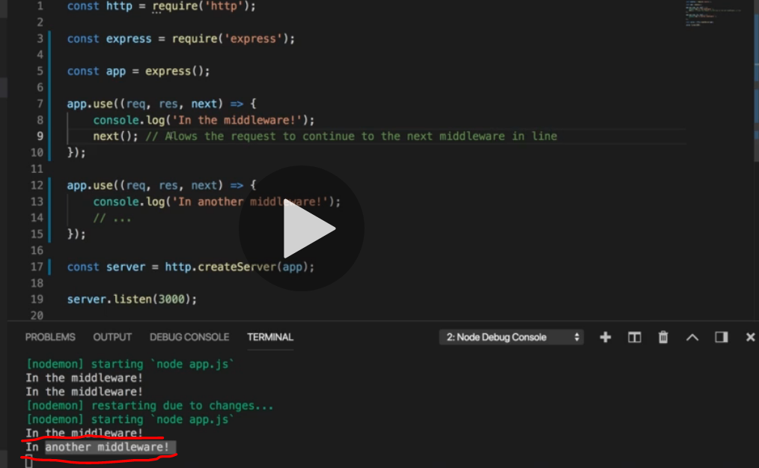

So that we can use app as function which containing request, response as we see earlier but the net is used for calling the next function of app if we do not write next it will not run the another function

We can also send the data to server which is by default in html

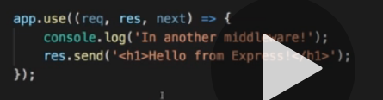

Res. Send is saving a lots of code because previously we are using a buffer and hole lots of code which we do not have to write because it is already written in the express js you can see it on their git repository of express code.

So express js will sort the repetitive coding part which is used more often so we can do our real operations

So we can use app.use in different ways if we do not write anything in that means it is applicable for all and we have to do next() to perform different operation which is below it but if we use app.use() with some path that will run in any case for that path only so we do not have to use next but if we write (./) only it means it applicable to all and it is default too.

 we can have more then 1 callBacks

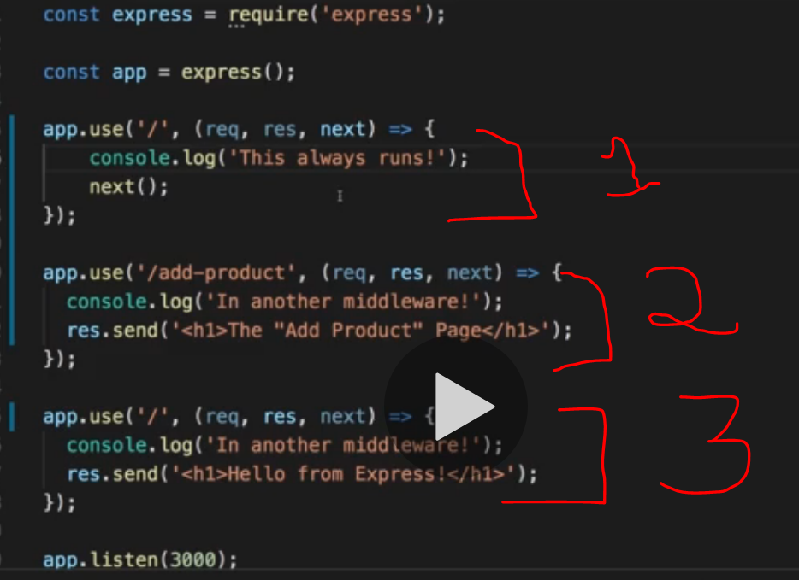

So the first one is applicable to all and we have to write next() to run the next on the list

The second one will run for the /add-productpage so we are not writing next because we do not want it to go down we only show that response only

And the third one is for all, so if we write add-product/something it will still open the product page

* Form Handling in express js

Form Handling is done by body parser in js from which we can parse JSON type of data, url encoded type of data and many more ( url encoded data is smoothing that is encode in form like your name)

So to enable body parser you have to first install body parser by 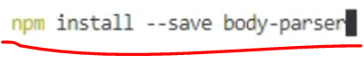it will save the parse file in our package dependencies

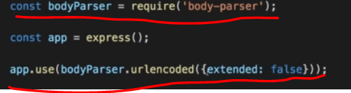

Just like we are using body parser by require and using it in the app where we are using url encoded method with seting default values as false.

Which can run  so from then you can see your object

We can also use get,post,delete etc in place of app.use

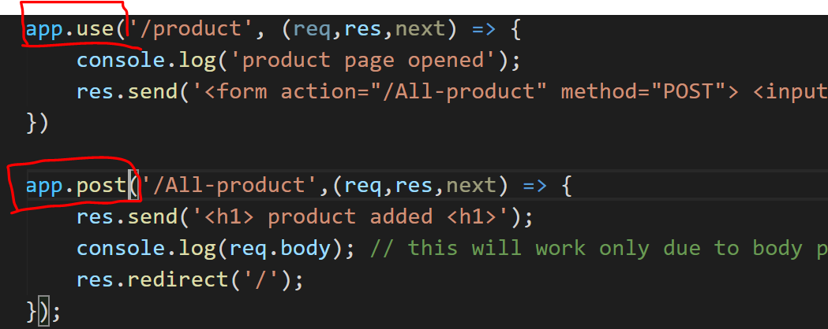

So the advantages of writing get,post ect instead of app.use is that they will run no matter where is the position of them and they will run

* OUT Source the routs

We can also out source the routs which means nothing but creating all the routs which we are creating as app.use,get or post in the different file that we can name it as routs and exporting them so that we can use it in our app.js files

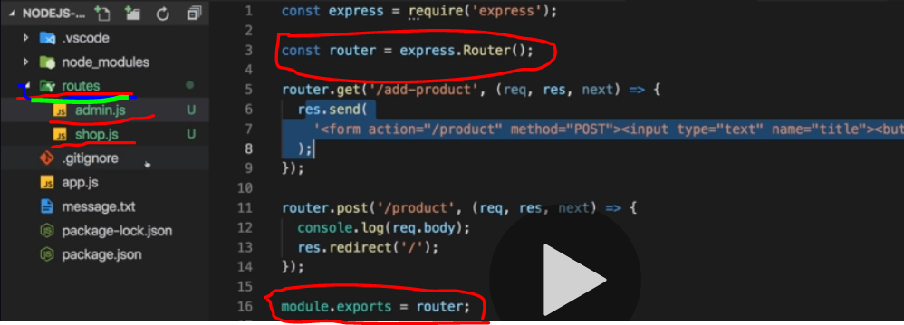

Here we are exporting routs in our admin,shop.js so we can export it into our app.js file

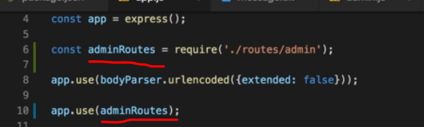

So their we are exporting admin.js by require in adminRoutes so that we can call it inside our app.use() which work same as it working so that we can listen our server by it.

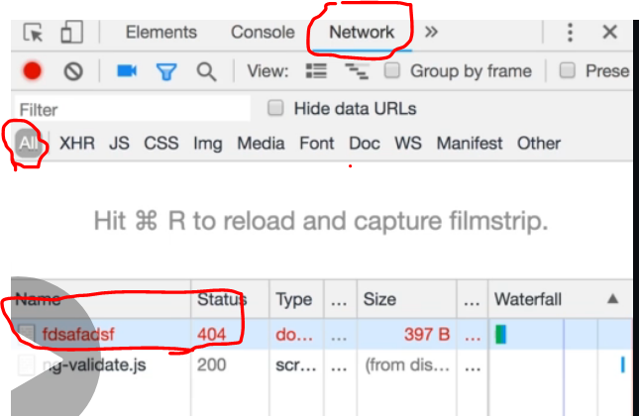 http://localhost:3500/fdgdfgdfg

We can also use it to display message for some status like error and we are doing it by

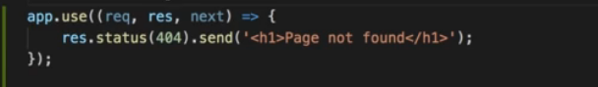

So we ca use these code at last to send h1 tag for the particular status obviously we have to use next or routs file before it so it can go down and check for every call best practice to calling by routs

* FILTER IN NODE JS

Filter is used to set up the common starting points so that instead of writing the /page address agin and agin we can write it a once.

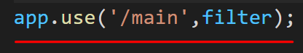

So that we can write export our filter without adding /main all the time we can write things ahed of it like /main/filter = /filter but we have to provide action as full address so that it can open that file /main/filter

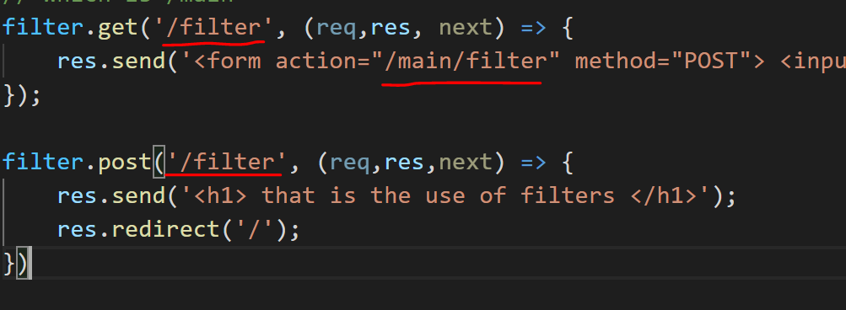

* HOW TO SEND HTML FILES TO USER

So instead of writing html in res.send above we can write a html page separately

* So we can write it by using res.sendFile() instead of using res.send() and give the file path.
* But if we try to put a path that will give error because sendFile takes the path in form of linux system which is( /fff ) but window have a path with ( \fff )
* So o over came this error we have to require(‘path’) 
* And then used is as  path.join will join the path so that any user can use it.
* __dirname in it is holding the absolute path of the folder so we can pass path from it
* But we have to give (.//) first because we are calling sendfile from some inside file so we are doing (.//) so that we can go to the root first and then give the path
* So we do not have to write (/) or (\) before any path
* The file from we are calling is shop.js
* 